****I Gobierno del

**Estado de México**

Escuela Preparatoria Oficial No. 82

“José Revueltas”

“Hay que alcanzar la exaltación verdadera, para lograrlo, hay que ser serenos, sin prisas, estudiar, trabajar y disciplinarse”

Profesora: Silvia Andrea Jasoo Cruz

**Materia: Inglés II**

**http://www.jgbb.com.mx**

Name __________________________________2nd. Semester, Group: __________________________________

Shift: _____________________ D**ate: _________________.**

**Exercises semana 2**

**Superlatives**

**Clases en linea.**

1. **Cambia los siguientes adjetivos a superlativos y escribe su significado en español.**

|  |  |  |
| --- | --- | --- |
| **Adjetivo** | **Superlativo** | **Significado en español** |
| **Tall** | **Tallest** | **El más alto** |
| **Short** |  |  |
| **Big** |  |  |
| **Small** |  |  |
| **Easy** |  |  |
| **Difficult** |  |  |
| **Handsome** |  |  |
| **Beautiful** |  |  |
| **Thin** |  |  |
| **Chubby** |  |  |
| **Dirty** |  |  |
| **Clean** |  |  |
| **Old** |  |  |
| **New** |  |  |
| **Fast** |  |  |
| **Slow** |  |  |
| **Ugly** |  |  |
| **Young** |  |  |

1. **Responde las preguntas con tu información. Observa el ejemplo.**

**Example:**

What is the most difficult subject in school?

**Reading comprehension is the most difficult subject for me.**

1. What is the most beautiful music for you?

___________________________________________________

1. Who is the tallest person in your family?

___________________________________________________

1. Who is the oldest person in your family?

___________________________________________________

1. What is the cleanest bedroom in your house?

___________________________________________________

1. Who is your best friend?

___________________________________________________

1. What is the best movie for you?

___________________________________________________

1. What is the easiest subject for you?

___________________________________________________

1. What is the most beautiful book for you?

___________________________________________________

1. Who is the youngest person in your family?

___________________________________________________

1. What is the newest cell phone in your country?

___________________________________________________

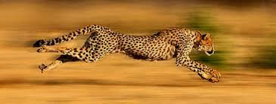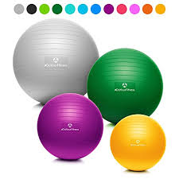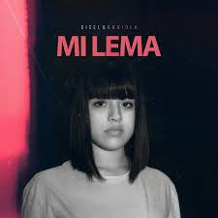

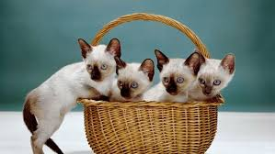

1. **Observa las imágenes para completar las oraciones. Atención al ejemplo.**

**Example: Gisela Gaxiola is one of the biggest (big)rap singer in Mexico.**

1. The yellow ball is ___________(small) of the four.
2. The girl is ___________ (short) person of the family.
3. Cheetah is _____________(fast) animal of the world.
4. Cats and pigs are _______________(clean) animals in the animal world.
5. These are ______________(new) pants in the store.
6. **Elabora cinco (5) oraciones similares a las del ejercicio III, con el tema de superlativos, utilizando los adjetivos young, ugly, slow, dirty, thin.**

**1._______________________________________________________________**

**2.________________________________________________________________**

**3.________________________________________________________________**

**4.________________________________________________________________**

**5.________________________________________________________________**